Detecting and Preventing Credit Card Fraud Through Code-Based Solutions
Lora Abeyta, Stephanie Furst, Joshua Kosakowsky
University of Colorado Boulder
Unstructured and Distributed Data Modeling & Analysis
Dr. Zhiyi Wang
April 6, 2026
Abstract
The increasing reliance on digital financial transactions has heightened the importance of detecting fraudulent activity. This paper examines a large-scale credit card transaction dataset through exploratory data analysis (EDA) to better understand its structure, variables, and patterns relevant to fraud detection. The dataset contains over 1.29 million transactions and includes financial, demographic, geographic, and temporal variables. The analysis focuses on data preparation, descriptive statistics, temporal trends, categorical patterns, and geographic relationships. Results reveal key challenges such as class imbalance and skewed transaction distributions, as well as valuable predictive signals in time-based and location-based features. The findings highlight the importance of multi-dimensional analysis in identifying fraud and provide insight into how such datasets can inform predictive modeling and business decision-making.
Introduction
Credit cards have become one of the most widely used payment methods in today’s economy, offering convenience and accessibility to millions of consumers. However, this convenience is accompanied by a growing challenge: fraudulent transactions. The financial, emotional, and institutional costs associated with credit card fraud are substantial, affecting individuals, businesses, and public institutions alike. As fraudulent activity continues to rise, the need for effective detection and prevention methods becomes increasingly urgent. Recognizing these widespread impacts, this paper explores the importance of developing a code-based solution aimed at identifying and preventing fraudulent credit card transactions.
The motivation for addressing this issue stems from both professional and personal experiences, particularly through the work and lives of Josh and Stephanie. From Josh’s perspective, working directly with college students has made the impact of fraud especially tangible. In his role, he regularly connects with students whose accounts have been affected by fraudulent charges. What often begins as a seemingly small issue can escalate quickly, leaving students unable to meet their financial obligations and, in some cases, sending accounts to collections. This creates long-term financial consequences and adds stress during an already demanding period of their lives. It also places a burden on educational institutions, where time and resources must be diverted to resolving financial issues rather than supporting academic success.
Stephanie’s perspective reflects both personal and professional experience. Her family has been directly impacted by credit card fraud, exposing the frustration and uncertainty involved in resolving fraudulent activity. Professionally, she works at Edward Jones, where fraud prevention is a critical priority. Through extensive training, she has developed a strong understanding of how frequently fraud occurs and the importance of early detection. Together, these experiences highlight the real-world consequences of fraud and reinforce the need for more effective detection systems.
These experiences underscore a broader issue: credit card fraud is not an isolated problem but a systemic one with far-reaching consequences. From students facing collections to families dealing with financial hardship and institutions allocating significant resources to fraud management, the ripple effects are extensive. Fraudulent transactions contribute to wasted financial resources, decreased productivity, and diminished trust in financial systems.
Dataset and Methods
Our group relied heavily on a logistic regression model as the primary approach for fraud detection, mainly because it strikes a balance between performance and efficiency. Since we were working with approximately 1.3 million transactions in PySpark DataFrames, we needed a model that could scale well without becoming too computationally expensive. A logistic regression (LR) and random forest (RF) baseline were both established for subsequent comparisons. To evaluate the effectiveness of feature engineering and class imbalance corrections, LR was selected due to its computational efficiency and low cost. This made it a practical choice for building a system capable of processing data at scale while still producing reliable predictions.
From a coding and methodological standpoint, logistic regression aligned well with our feature engineering approach and pipeline structure, as it operates effectively on numerical inputs. For text-based categorical variables, one-hot encoding was applied to convert these features into numerical representations, enabling the model to utilize them efficiently. After using groupBy and aggregation functions to compute fraud patterns and creating additional columns like hour of day and category-based features, the model was able to take in these inputs and learn meaningful relationships. We evaluated several approaches to address class imbalance, including random undersampling, which reduces majority class bias but risks discarding valuable information, and simple oversampling through duplication, which can improve minority class representation but may increase the risk of overfitting. We ultimately selected class weighting, as it preserves the full dataset while adjusting the model’s loss function to place greater emphasis on rare fraud cases, resulting in a more balanced and generalizable performance. Combined with Spark MLlib, this allowed us to build a streamlined and efficient machine learning pipeline that aligned with our goal of creating a scalable and cost-effective fraud detection system.
The dataset analyzed consists of 1,296,675 credit card transactions with 24 original variables, expanded to 37 after feature engineering then refined after determining the most advantageous columns. These variables include transaction details, customer demographics, merchant information, and geographic coordinates. Temporal features such as hour, day, month, and weekday were derived from transaction timestamps to support behavioral analysis.
Feature engineering played a central role in turning raw transaction data into meaningful inputs for the fraud detection model. One of the biggest challenges was class imbalance, since fraud makes up only a very small percentage of transactions, so features were intentionally designed to amplify weak fraud signals and improve recall for these rare events. Based on patterns observed earlier, features like transaction amount buckets, category-level fraud rates, and time-based variables such as is_night and is_weekend were created to capture behavioral differences between fraud and non-fraud activity. At the same time, additional behavioral and geographic features like location and user demographics were explored, but ultimately not all were used because they introduced more noise than useful signal. This shows that feature engineering is not just about adding more variables, but about selecting the ones that actually improve model performance.
To effectively approach the problem of fraud detection, our group implemented a structured pipeline designed for both scalability and accuracy. We began with data ingestion, loading large-scale transaction data into the system, and then used PySpark DataFrames to efficiently process and manage the distributed dataset. From there, we applied feature engineering techniques such as extracting time-based variables, computing category-level fraud rates, and creating transaction-based features that reflect real behavioral patterns. These engineered features were then used to train machine learning models using Spark MLlib, allowing us to build a system capable of identifying fraud at scale. This step-by-step approach ensured that both the data processing and modeling decisions were aligned with the goal of accurately detecting fraudulent transactions.
Our group ultimately found that logistic regression was the best choice for testing with this dataset because it aligned well with both the structure of the data and the goals of the project. Since fraud signals can often be sparse and subtle, logistic regression does a good job of picking up on those linear relationships while still being easy to interpret. It also performs well at scale, which was important given the size of our dataset and the need to run everything efficiently in PySpark. Compared to more complex models, it allowed us to train quickly, iterate faster, and keep computational costs low, all while maintaining strong performance. This made it a reliable baseline and, in many ways, the most practical option for optimization, testing modifications, and building a scalable fraud detection system.

At the same time, we also explored using a random forest model to capture more complex, non-linear patterns in the data. With a tree depth of 14, the model was able to identify more intricate interactions between features that logistic regression might miss, especially when it comes to more nuanced fraud behavior. This added some performance benefits in terms of detecting harder cases, but it came at the cost of speed and computational efficiency. Training and running the random forest was significantly slower, especially at scale, which made it less practical for our overall pipeline. So while it was useful for comparison and understanding deeper patterns, logistic regression remained the better choice for balancing accuracy, speed, and scalability.
Building on our model selection, the next step was evaluating how well logistic regression actually performs, which is where the ROC curve becomes exceptionally useful. The curve shows a strong tradeoff between true positive rate and false positive rate, and overall the model achieves solid performance in separating fraud from non-fraud transactions. You can see that even at relatively low false positive rates, the model is able to capture a large portion of fraud cases, which reinforces why logistic regression worked well for this problem. It confirms that even with a simpler, more efficient model, we were still able to achieve meaningful predictive power.
However, selecting the right classification threshold turned out to be just as important as choosing the model itself. The threshold tradeoff visual highlights how adjusting this cutoff directly impacts recall and false positives. For example, lowering the threshold increases recall and allows us to detect more fraud, but it also leads to a large spike in false positives, with around 3,000 additional legitimate transactions being flagged. On the other hand, increasing the threshold reduces false positives but results in missing around 34 fraud cases. This creates a clear tradeoff where improving detection comes at the cost of customer experience, and finding the right balance becomes a key decision.
This tradeoff is further illustrated in the confusion matrix at the selected threshold of 0.525. At this point, the model correctly identifies a large number of non-fraud transactions while still capturing a significant portion of fraud cases. There are 858 true positives and only 350 false negatives, which is important because missed fraud is considered the most critical error. At the same time, there are 5,382 false positives, which reflects the cost of being more aggressive in fraud detection. These numbers show that the model is prioritizing catching fraud, even if it introduces some level of customer friction.

While a random split was used for training and testing purposes in this project, a temporal split was also explored given the nature of fraud detection. Splitting the data by time, using earlier transactions for training and more recent ones for testing, more closely reflects how a production system would operate, where historical patterns are used to predict future fraud. In practice, however, this approach did not yield significant improvements in model performance for this dataset, likely due to its relatively limited time range. That said, a time-based split could be more appropriate standard in a real deployment environment, where capturing the most current fraud patterns is critical to maintaining model accuracy over time.
Overall, fraud detection is not just about building a strong model, but also about making strategic decisions around thresholds and evaluation metrics. Our focus was on minimizing false negatives, since missing fraud has a direct financial impact, even if that meant accepting a higher number of false positives. This ties back to our earlier choices with logistic regression, where we prioritized scalability and efficiency while still maintaining strong detection performance. By combining a well-performing model with thoughtful threshold tuning, we were able to build a system that balances accuracy, cost, and real-world usability.
Results and Insights
From our combined analysis and visualizations, we observed several consistent patterns that strengthen our understanding of how fraud can be detected. Transaction amounts show a clear right-skewed distribution, with most purchases being small and only a few high-value transactions. While large transactions may appear suspicious, fraud occurs across all transaction sizes, indicating that amount alone is not a reliable indicator.
We also observed a strong class imbalance, with fraudulent transactions representing only a small fraction of total activity. This presents a major challenge, as detection systems must identify rare fraudulent events without incorrectly flagging legitimate transactions. Our findings emphasize the importance of using appropriate evaluation methods rather than relying solely on accuracy.

Figure 1
Fraud By Transaction Amount
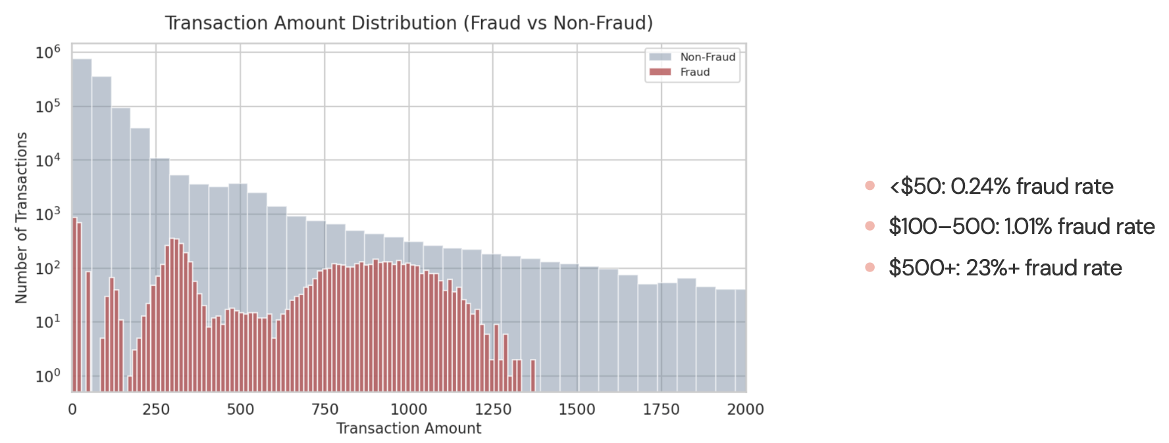

Looking at Figure 2 non-fraud transactions clearly follow a pretty predictable daily rhythm. Activity is lower during the early morning hours, gradually increases throughout the day, and peaks around typical business hours when people are most active. This makes sense because most legitimate purchases happen when people are awake, working, or running errands. After the evening, the number of non-fraud transactions starts to taper off again as fewer people are making purchases late at night. Temporal analysis reinforces this idea, showing that transaction activity tends to follow consistent daily (and even weekly) patterns, which reflect normal human behavior and routines.
In contrast, fraud transactions don’t follow this same pattern and instead show unusual spikes, especially later at night between around 10 PM and 4 AM. While there is some increase around midday, the most noticeable difference is how fraud activity jumps during hours when legitimate activity is relatively low. These deviations from expected patterns highlight how fraudulent transactions often occur at unusual times, making them stand out from normal behavior. Because of this, time-based features like the hour of the day can be strong indicators when building fraud detection models. If a transaction happens at a time that doesn’t align with typical activity, it raises a red flag, showing how useful temporal features are for identifying anomalies

Figure 2
Transaction Activity By Hour
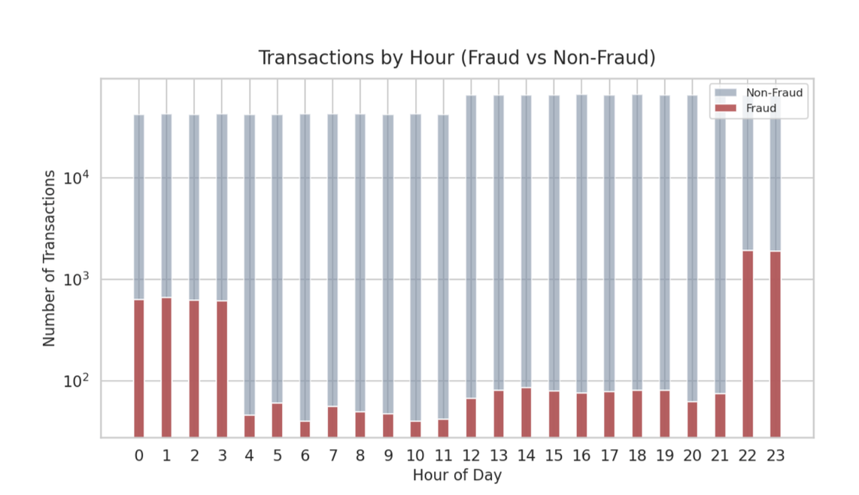

Looking at the day-of-week breakdown, fraud patterns become even more interesting because they don’t stay uniform across the week like non-fraud transactions tend to. Legitimate transactions are relatively steady from Monday through Sunday, with only small increases toward the weekend as people have more time to spend. But fraud shows a clearer uptick on the weekends, especially toward the end of the week, which suggests that fraudulent activity is taking advantage of periods when behavior is less predictable and monitoring might be less strict. This aligns with the idea that fraud doesn’t just happen randomly; it often follows its own patterns that differ from normal consumer habits.
Including the day-of-week variable really helps capture these differences because it adds important context to when a transaction occurs. When combined with other variables like time of day, it allows models to better distinguish between normal and suspicious behavior. For example, a late-night transaction on a Friday or Saturday might be more common for legitimate users, but it still carries a different risk profile compared to the same transaction on a weekday. By incorporating these temporal features, especially weekly patterns, the model becomes more sensitive to subtle shifts in behavior, making it more effective at identifying fraud that might otherwise blend in with normal activity.

Figure 3
Fraud By Day Of The Week
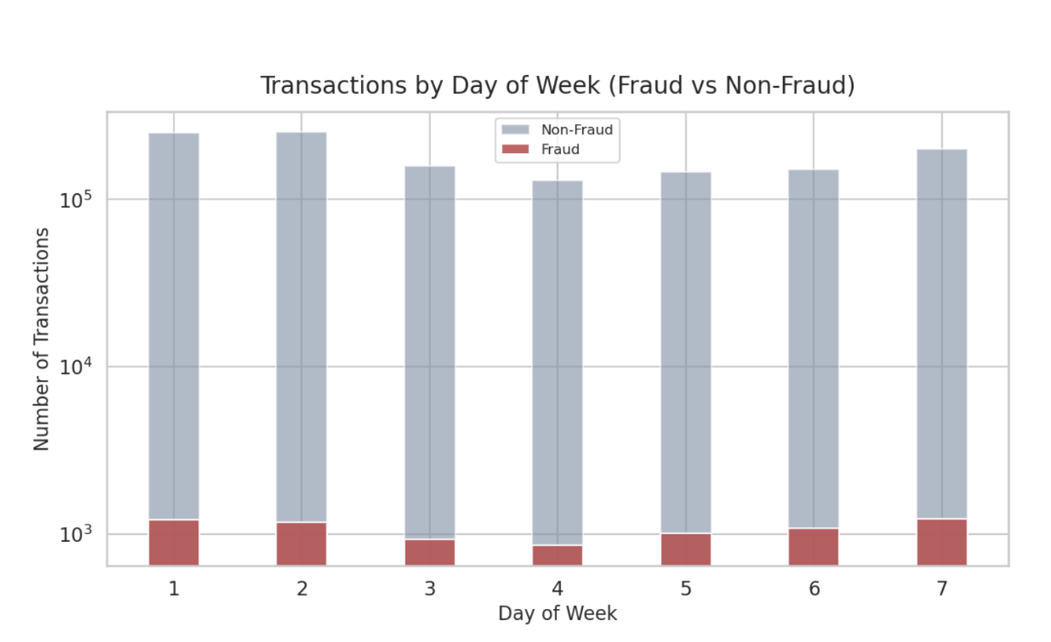From our analysis of the fraud transaction location visuals in Figure 4 and Figure 5, we identified several important geographic patterns that provide insight into how fraudulent activity is distributed across the United States. By examining both the state-level heatmap and the point-based location plots, we are able to better understand where fraud is most concentrated and how it spreads geographically.
At the state level, fraud is not evenly distributed. Certain states, particularly large and highly populated ones such as Texas, California, New York, and Pennsylvania, show higher concentrations of fraudulent transactions. This pattern suggests that fraud volume is partially influenced by population size and transaction density. However, the variation in intensity across states also indicates that fraud is not solely driven by population, as some states exhibit disproportionately higher levels relative to others. This implies that regional factors, such as economic activity, transaction volume, or exposure to certain types of merchants, may contribute to increased fraud risk.

Figure 4
Fraud Transactions By State
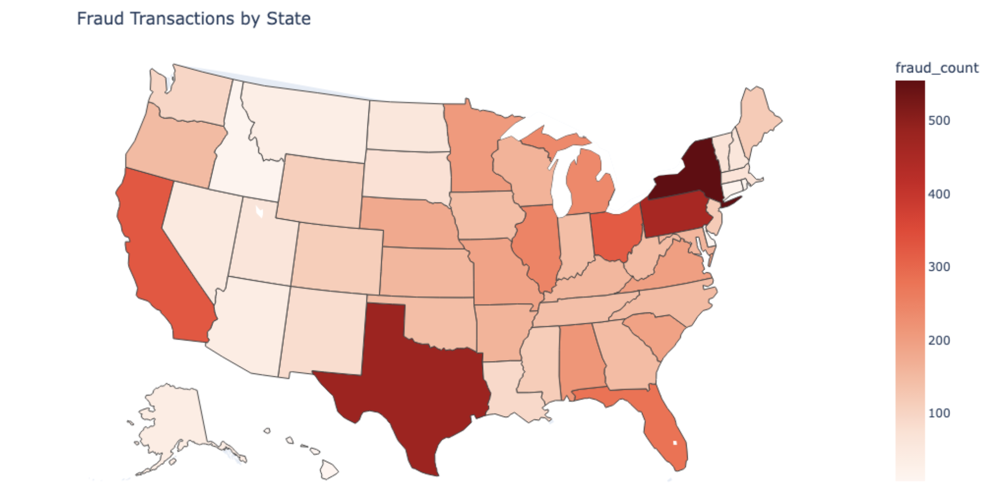

When we examine the point-based location visuals in Figure 5, a more detailed pattern emerges. Fraudulent transactions are widely dispersed across the country, but they tend to cluster in urban and metropolitan areas. Dense clusters are visible along the East Coast, particularly in the Northeast corridor, as well as in parts of the Midwest and along the West Coast. These clusters likely reflect areas with higher transaction activity, where more opportunities for fraud exist. At the same time, the presence of fraud points in less densely populated regions indicates that fraud is not limited to major cities and can occur across a broad geographic range.

Figure 5
Fraud Transaction Location Cluster
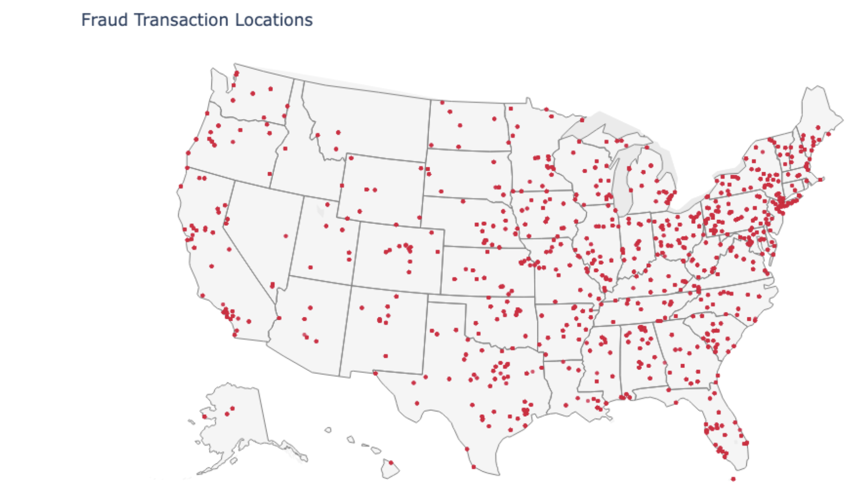

Another key insight comes from comparing the distribution of fraud locations to transaction amounts. The visualization that incorporates transaction amount shows that higher-value fraudulent transactions are scattered throughout the country rather than concentrated in a single region. This suggests that while fraud frequency may cluster geographically, the severity of fraud, in terms of transaction amount, does not follow the same pattern. High-value fraud can occur in both dense urban centers and more rural areas, reinforcing the need for consistent monitoring across all regions.
Additionally, the visuals highlight the importance of geographic consistency in fraud detection. Most legitimate transactions are expected to occur within a predictable range relative to a customer’s location. The widespread and sometimes unexpected distribution of fraudulent transactions suggests potential mismatches between customer and merchant locations. These spatial inconsistencies serve as strong indicators of suspicious activity and support the use of geographic features in fraud detection models.
Our analysis shows that fraudulent transactions exhibit both clustering and dispersion. While higher concentrations appear in populous and economically active regions, fraud is ultimately a nationwide issue that affects both urban and rural areas. These findings reinforce the importance of incorporating geographic data into fraud detection systems, as location-based patterns provide valuable signals for identifying anomalous behavior. By combining geographic insights with other dimensions such as time, transaction type, and amount, we can develop more effective and comprehensive approaches to detecting and preventing fraud.
Figure 6 shows that fraud rates vary significantly across transaction categories, which makes category a really powerful feature for identifying fraud. For example, categories like shopping_net, misc_net, and grocery_pos have noticeably higher fraud rates compared to others like entertainment or personal care. This tells us that fraud is not randomly distributed, but instead concentrated in specific types of transactions. From a modeling perspective, this is important because it gives clear signals about which categories are inherently riskier, allowing us to differentiate between normal and suspicious behavior more effectively.
In a PySpark or Python workflow, these differences can be transformed into meaningful features that enhance model performance. One approach involves calculating the historical fraud rate for each category and joining it back into the dataset as a new feature, allowing each transaction to carry additional context regarding the relative risk of its category. Categories can also be encoded using techniques such as one-hot encoding or target encoding, enabling machine learning models to interpret them more effectively. Given that the visual highlights categories such as online shopping and miscellaneous transactions as having the highest fraud rates, the model can learn to assign higher probabilities of fraud to transactions within these groups.

Figure 6
Top Categories By Fraud
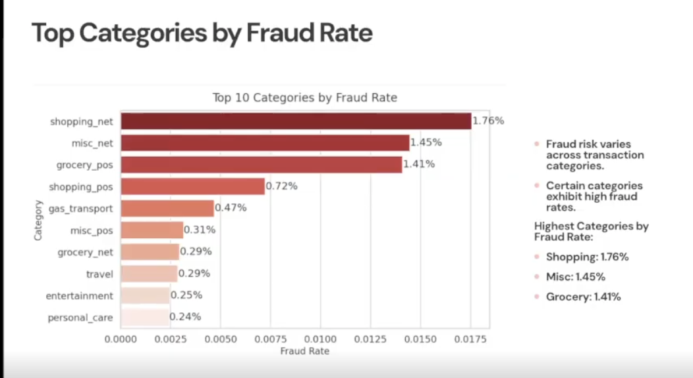

Re-examining the dataset for columns that correlate with fraud detection shows that the strongest relationships are concentrated around transaction amount and features engineered directly from that variable. The visual highlights that high_amt_flag has the highest correlation with fraud (0.25), followed by amt (0.22), avg_amt_per_card (0.21), and amt_vs_avg (0.20), all of which capture different dimensions of spending behavior. This pattern reinforces that deviations in transaction size, whether absolute or relative to a user’s historical behavior, are key indicators of fraudulent activity. In contrast, amt_log exhibits a weaker correlation (0.12), suggesting that while log transformations can stabilize variance, they may reduce the impact of extreme values that are informative for fraud detection. Additionally, features such as is_night (0.03) contribute minimal explanatory power, further emphasizing that transaction amount is the dominant signal.
Despite earlier tests that incorporated amt_log, the stronger performance of high_amt_flag indicates that threshold-based indicators of unusually large transactions provide a clearer and more direct signal for identifying fraud. As a result, models were re-run using high_amt_flag in place of weaker transformations to evaluate whether emphasizing these high-risk transaction markers would lead to measurable improvements in predictive performance.
Figure 7
Fraud Correlations
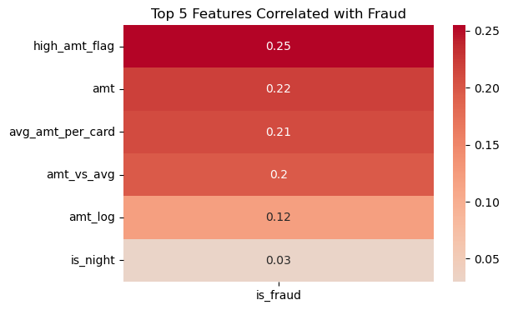

Conclusion
In conclusion, our analysis demonstrates that effective fraud detection is not driven by any single variable or model, but rather by the combination of thoughtful data exploration, feature engineering, and scalable machine learning. Across the dataset of over 1.29 million transactions, we consistently found that fraud does not occur randomly, but instead follows identifiable patterns across time, category, and geography. Temporal features revealed that fraudulent activity often spikes during late night hours and increases on weekends, while category level analysis showed that certain transaction types carry inherently higher risk. Geographic patterns further reinforced that fraud is both clustered and widespread, with concentrations in high density regions but presence across the entire country. Together, these insights highlight the importance of a multi dimensional approach to fraud detection that captures behavioral inconsistencies rather than relying on any single indicator.
From a modeling perspective, our group focused on building a system that balances accuracy, efficiency, and scalability. Logistic regression proved to be the most practical choice, as it handled large scale data effectively while still capturing meaningful patterns in sparse fraud signals. While more complex models like random forests were able to detect additional non linear relationships, they came at a significant computational cost and were less suitable for a distributed PySpark environment. By engineering features such as transaction amount buckets, category level fraud rates, and time based variables, we were able to enhance the model’s ability to distinguish between normal and fraudulent behavior. Just as importantly, we addressed the challenge of class imbalance through techniques like class weighting, ensuring that rare fraud cases were not overlooked.
It is also worth noting that logistic regression and random forest are not mutually exclusive, but complementary tools suited to different customer segments. Logistic regression works well for lower-risk customers, such as long-term cardholders with established spending histories, where interpretability and speed are priorities. Random forest may be better suited for higher-risk segments, such as new customers, those in high fraud density areas, or frequent travelers, where non-linear patterns carry more predictive value. A tiered approach that routes transactions to the appropriate model based on customer risk profile could capture the strengths of both.

Another key takeaway from this project is that model performance is not just about accuracy, but about making strategic decisions based on real world tradeoffs. Through evaluation metrics like ROC curves, threshold tuning, and confusion matrices, we saw how adjusting the classification threshold directly impacts both fraud detection and customer experience. Lower thresholds improve recall but introduce a large number of false positives, while higher thresholds reduce customer friction at the cost of missed fraud. Our approach prioritized minimizing false negatives, recognizing that missed fraud carries a greater financial and operational impact. This reflects a broader reality in fraud detection systems, where the best model is not necessarily the most complex, but the one that aligns with business goals and risk tolerance.
Overall, this project reinforces that building an effective fraud detection system requires both technical and practical considerations. By leveraging scalable tools like PySpark, engineering meaningful features from real behavioral patterns, and carefully tuning model decisions, we were able to develop a system that performs well in a real world context. More importantly, the findings emphasize that fraud detection is an ongoing process that must adapt to evolving patterns and behaviors. As digital transactions continue to grow, combining data driven insights with efficient modeling approaches will be critical in reducing fraud, protecting consumers, and maintaining trust in financial systems.

References
Bhattacharyya, S., Jha, S., Tharakunnel, K., & Westland, J. C. (2011). Data mining for credit card fraud: A comparative study. Decision Support Systems, 50(3), 602–613.
Bolton, R. J., & Hand, D. J. (2002). Statistical fraud detection: A review. Statistical Science, 17(3), 235–255.
Dal Pozzolo, A., Caelen, O., Le Borgne, Y. A., Waterschoot, S., & Bontempi, G. (2014). Learned lessons in credit card fraud detection from a practitioner perspective. Expert Systems with Applications, 41(10), 4915–4928.
Federal Trade Commission. (2024). Consumer Sentinel Network data book 2023. Federal Trade Commission.
Jurgovsky, J., Granitzer, M., Ziegler, K., Calabretto, S., Portier, P. E., He-Guelton, L., & Caelen, O. (2018). Sequence classification for credit-card fraud detection. Expert Systems with Applications, 100, 234–245.
Meng, X., Bradley, J., Yavuz, B., Sparks, E., Venkataraman, S., Liu, D., & Talwalkar, A. (2016). MLlib: Machine learning in Apache Spark. Journal of Machine Learning Research, 17(34), 1–7.
OpenAI. (2026). ChatGPT (April 24 version) [Large language model]. https://chat.openai.com
(OpenAI, 2026)

